

-



Advance Data Science

Single-family loan data

Mid Term

**Team 5**

Ankit Bhayani

Rajat Agrawal

Vishakha Sawant

SUMMARY

The report summarizes the analysis performed on Single-family loan data, provided by Freddie Mac(<http://www.freddiemac.com/news/finance/sf_loanlevel_dataset.html>). The data provided by Freddie Mac consists of the following details:

*Mortgages originated from January 1, 1999, through the “Origination Cutoff Date”, with monthly loan performance data through the “Performance Cutoff Date,” that were sold to Freddie Mac or back Freddie Mac Participation Certificates (PCs).*

*• Fully amortizing 15-, 20-, and 30-year fixed-rate mortgages*

*• Mortgages categorized as having verified or waived documentation.*

We then build predictive analytics models using the datasets. The problem presented is divided into 2 section:

**Section 1: Data wrangling**

* Data Download and pre-processing
* Exploratory Data analysis

**Section 2: Building and evaluating models**

* **Prediction** using Linear Regression, Random Forest, Neural Network KNN Algorithms
* **Classification** using Logistic Regression, Random Forest, Neural Network, SVN Algorithms

1 PART 1: DATA INGESTION AND WRANGLING

1.1 THE DATA

***Single Family Loan-Level Dataset***

For each calendar quarter, there is one file containing loan **origination data** and one file containing **monthly performance data** for each loan in the **origination data file**.

Freddie Mac has created a smaller dataset for those who may not require, or have the capability, to download the full Dataset. The sample dataset is a simple random sample6 of 50,000 loans selected from each full vintage year and a proportionate number of loans from each partial vintage year of the full Single Family Loan-Level Dataset. Each vintage year has one origination data file and one corresponding monthly performance data file, containing the same loan-level data fields as those included in the full Dataset. Due to the size of the dataset, the data has been broken up and compressed as detailed below. The files are organized chronologically by year and quarter.

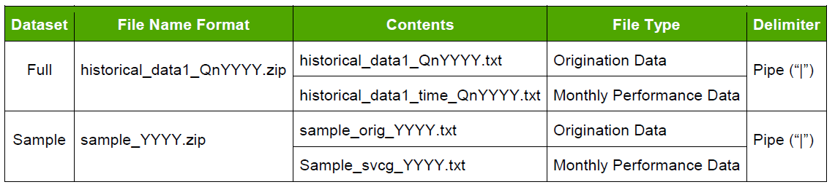

**Data Download and pre-processing:**

The very first challenge was to programmatically download the data from Freddie Mac website (<https://freddiemac.embs.com/FLoan/Data/download.php>) and download and preprocess the “SAMPLE” file both for origination and performance data.

To download the file programmatically, first the user should register him/herself by creating username and password. Once logged in, the user can download all the file required for analysis. We have used the python requests library for this purpose. To store the user credential, we need to store them in the request session so that user didn’t redirect back to the login page whenever he/she required to download a file from the Freddie Mac posted dataset.

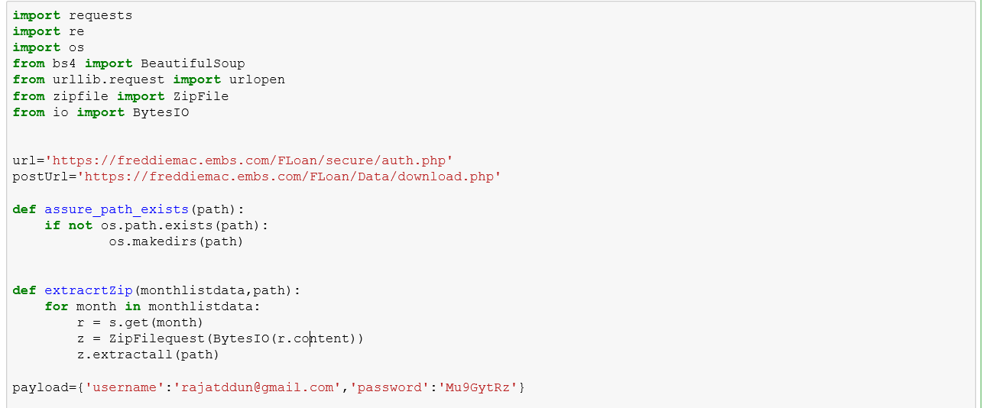

Once, the user is logged in to the website, we will be using request session to drive the further functionality. We will be using **Beautiful Soup** package, a powerful python package for data scrapping from the Freddie Mac Website and download all the “**Sample**” files for our analysis purpose.

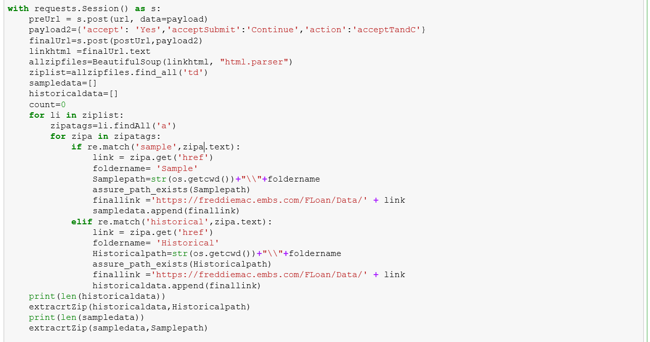

1.2 Data Preprocessing and Cleaning

Since, these files are big in size and consist of huge amount of data, we need to preprocess these files before getting saved in our drive. These Zip file consist of two files:

**Origination File:**

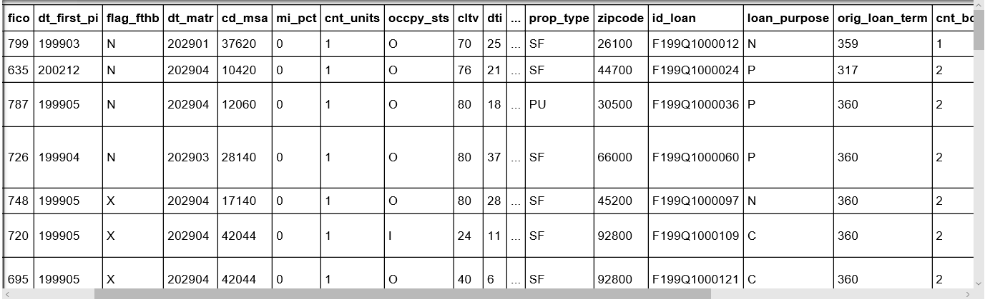For origination file, we first analyze the file size for all the year. Using python pandas, we create a data frame where we append all the data from the sample file for all the year. Origination file consist of 26 columns which consist of various details associated with the loan originated in each year. Some of the major columns are defined below:

We have many Null values and spaces (an invalid values) which we need to handle before using these files to compute a summary report. We must make sure that our data is in proper format with same datatype. We have created following functions:

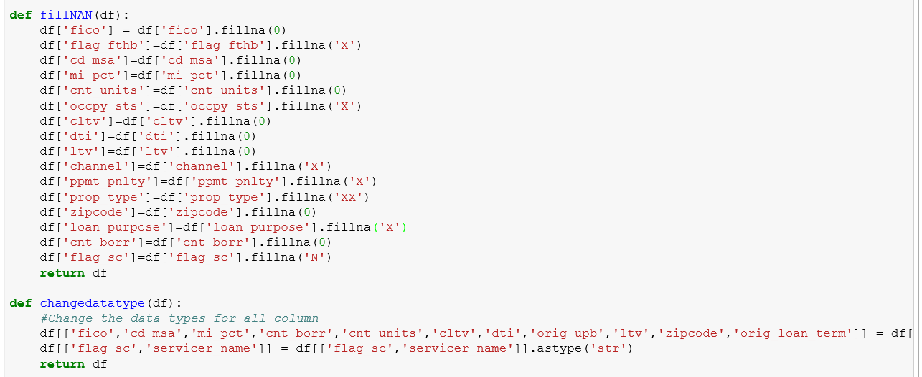

**Performance File:**

For performance file, we first analyze the file size for all the year. Using python pandas, we create a data frame where we append all the data for all the year. Performance file consist of 23 columns which consist of various information about the loan origination in a year. Since, the size of the file is very large, we decide to summarizes the input file for all the year during its preprocessing. Some of the major columns are defined below:

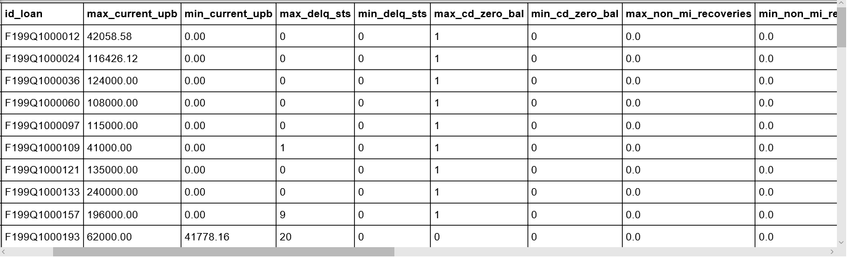

As we have many empty column values in our origination and preprocessing file, we need to clean those to ensure that we don’t have any NAN/NA value in our data. Also, we need to take care of the data type of column. These columns will be required while creating the summary matrices.

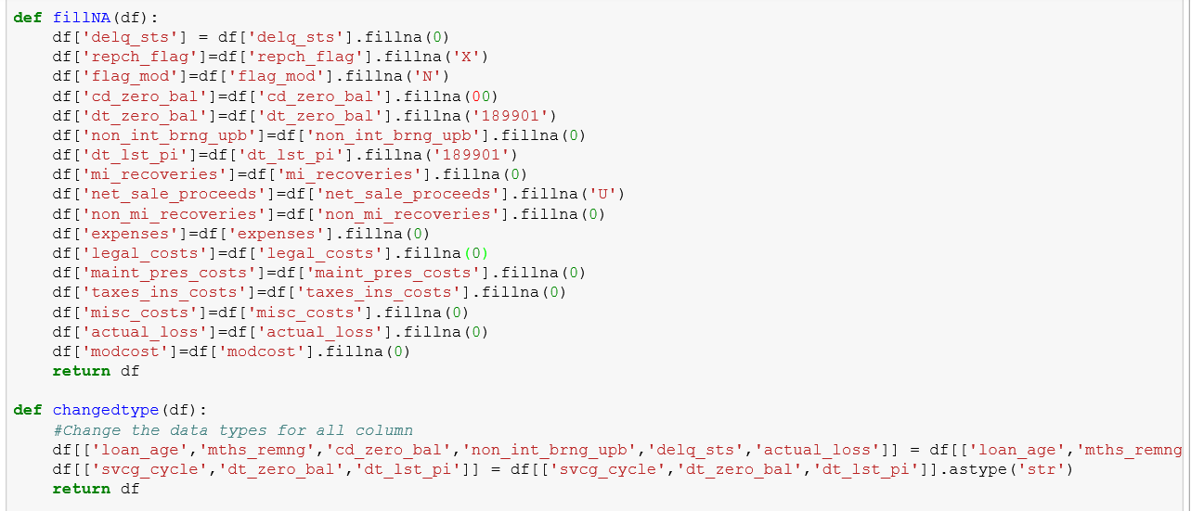

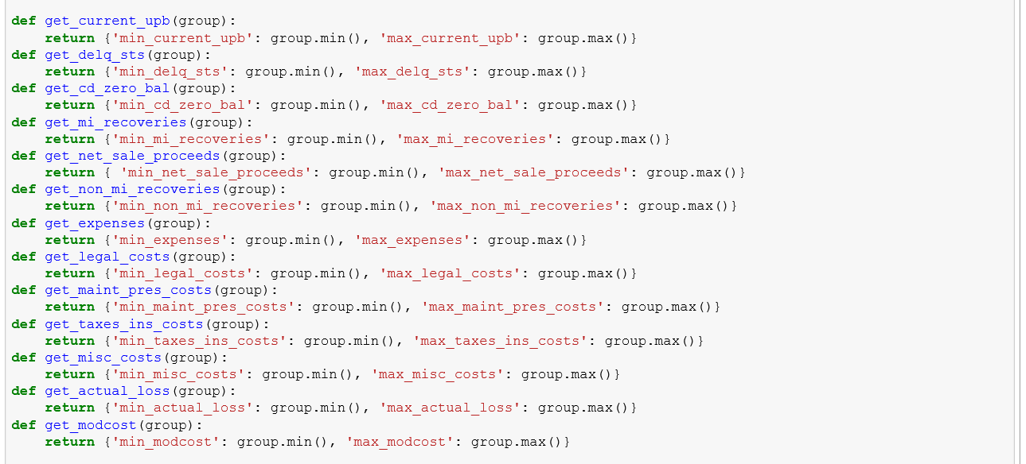Once, we are done with the cleaning of the performance file, we will create a summarized version of the file based on certain column which are important for us. For this step, we created a function which will get the Max/Min/Average value of the columns in our summarized performance file.

1.3 Creating Summarized CSV file (Output)

Once the preprocessing and data cleaning steps are performed, we will have created our final output file, one for origination file named ‘OriginationCombinedCode’ and for performance file named ‘PerformanceCombinedSummary’. These final files will be used for our analysis performed in part 2.

We have also created some derived column like ‘Year’ and ‘Quarter’ which will help to create the summary metrics.

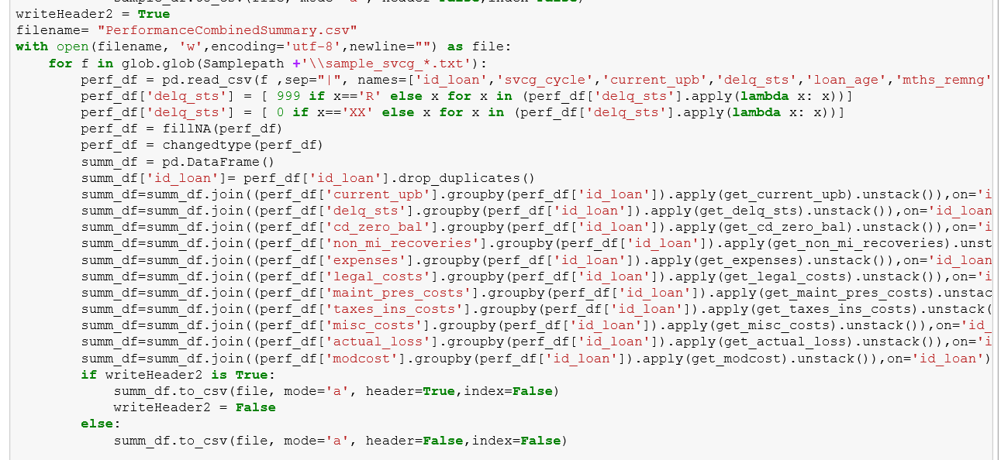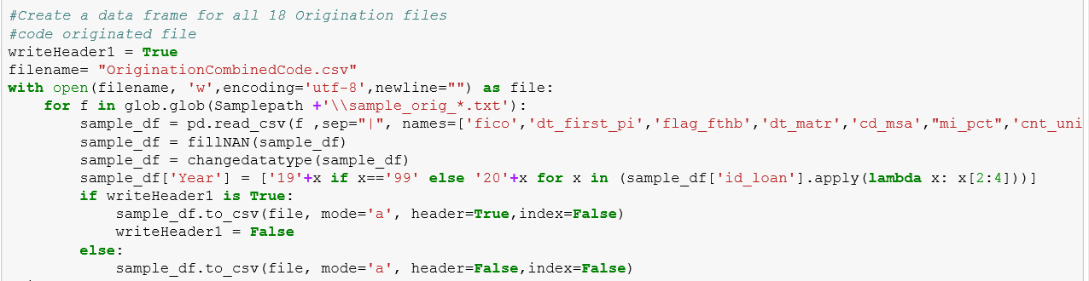

**NOTE:** As we are working on two different file, we need to know about the data and the relationship between the two files created. In origination file, we have idloan which is a unique loan sequence number with quarter and year of loan origination attached to it. In performance file, for a given year we have multiple rows associated with a loan number which depicts its performance. We don’t have any loan number duplicated in origination file with respect to year. It is always **Unique**.

PART 2: Exploratory Data Analysis

2.1 Analysis - Jupyter Notebook

In Part 2, we were asked to write Jupyter notebook using R/Python to graphically represent different summaries of data and summarize our findings in this notebook.

We first create a pandas’ data frame for the origination file and group the data on the year.

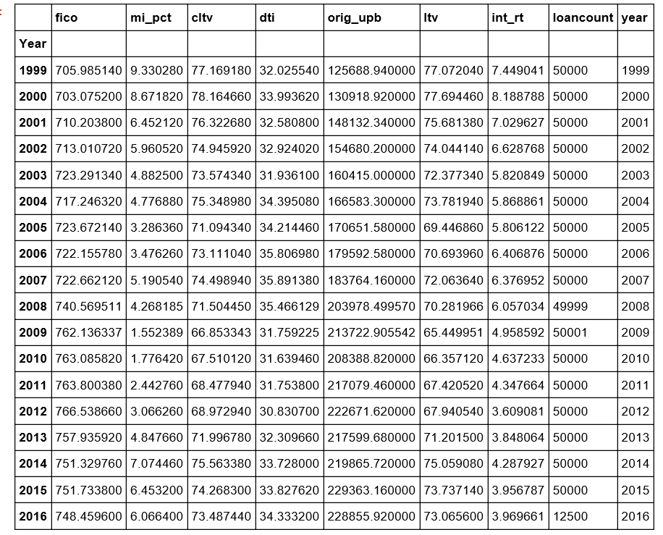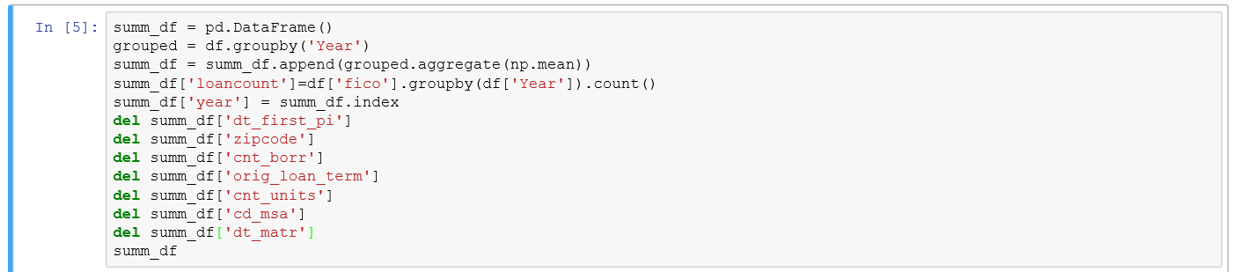

Here we show the various details associated with the origination file and the total loan count and mean of various important factor like fico score, interest rate based on year.

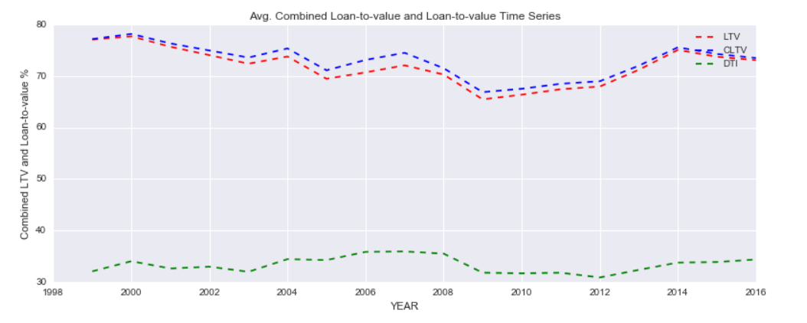**CLTV – LTV & DTI Comparison based on Year**

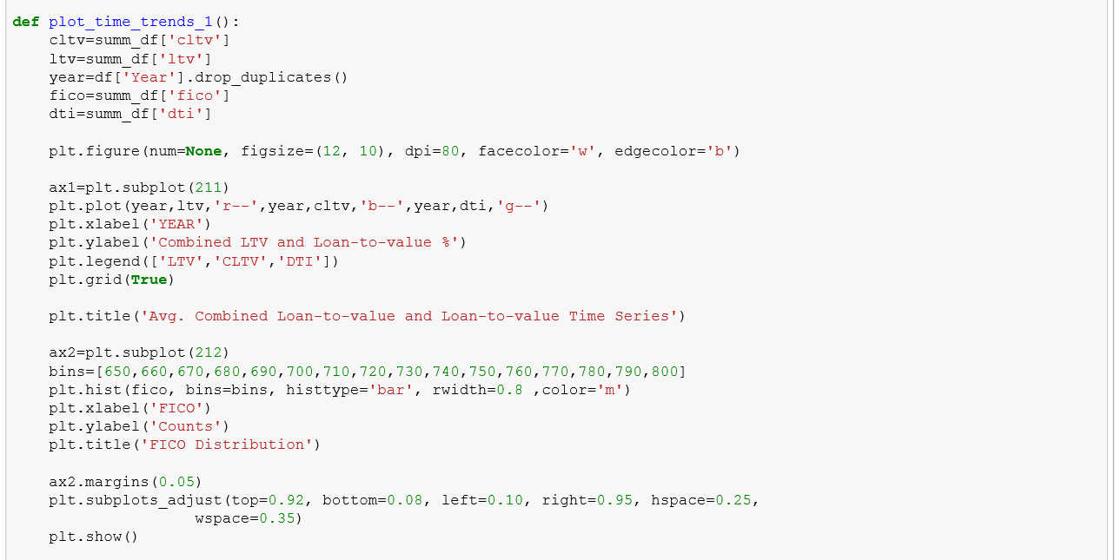



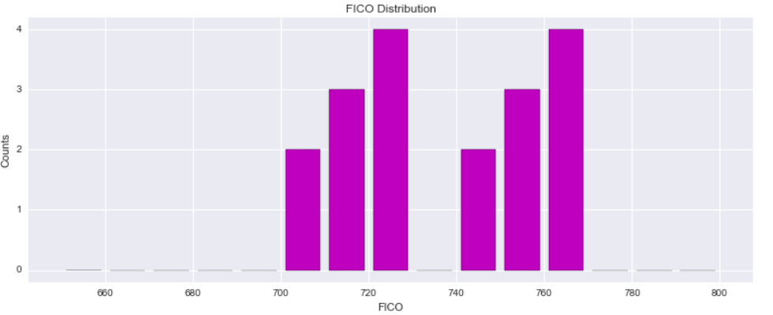**FICO Based on Count**

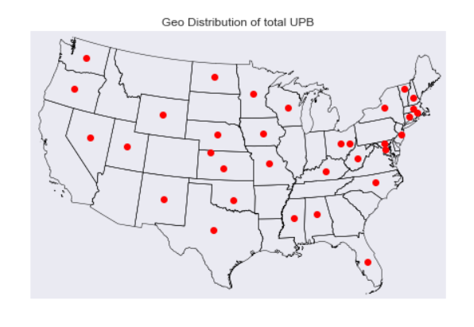**Count of Loan based on Geographical Presence**

**Average Fico Score based on Year**

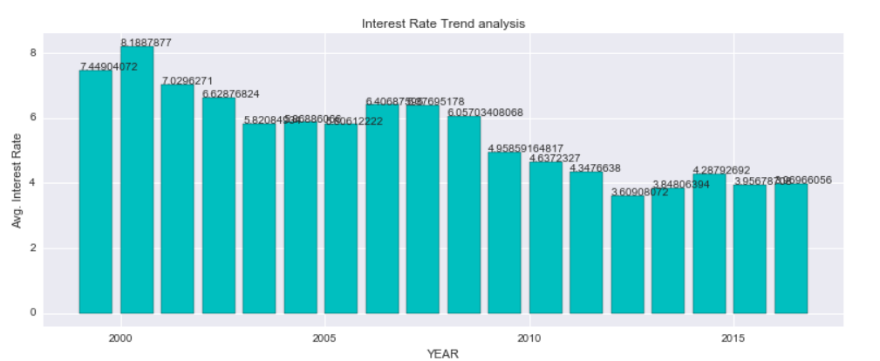

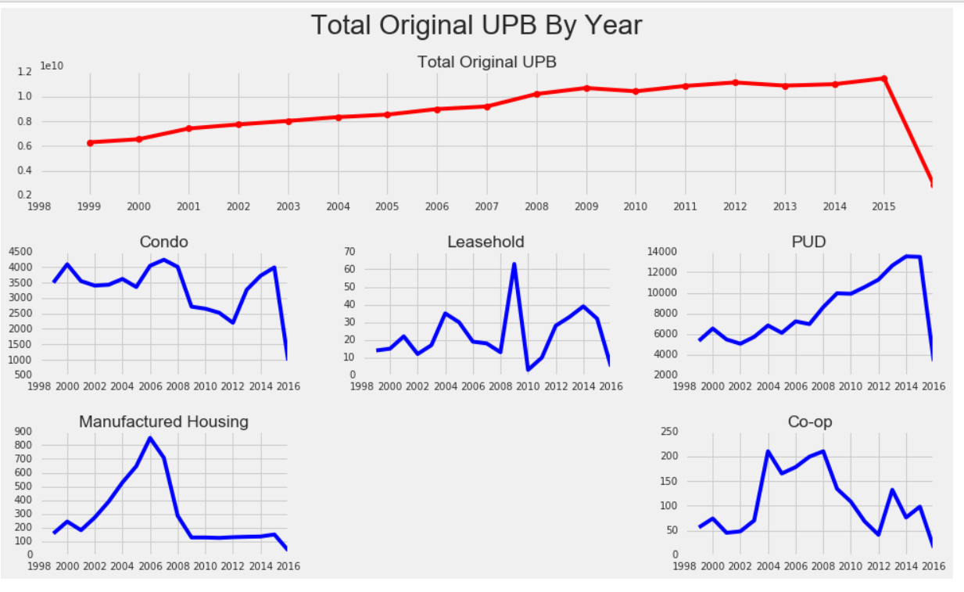**Average UPB based on Year**

**Total Loan Count by Purpose**

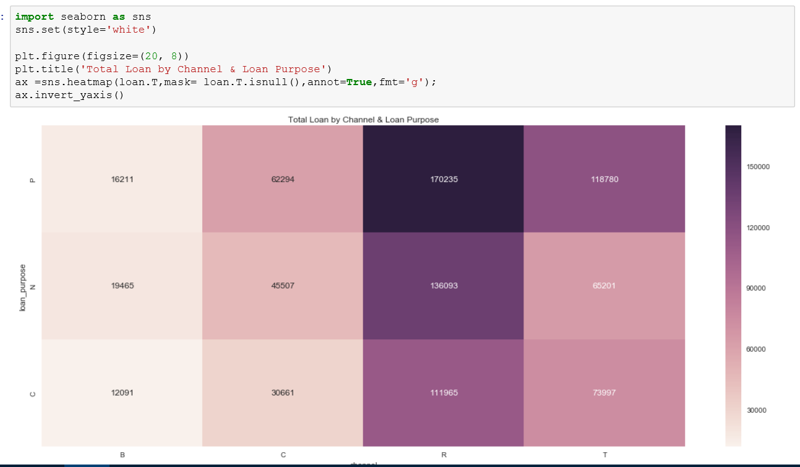

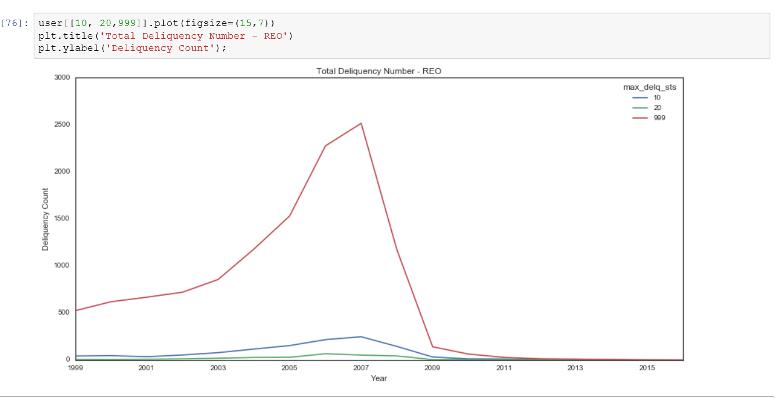**Total Deposition by Year**

**Top 25 Seller**

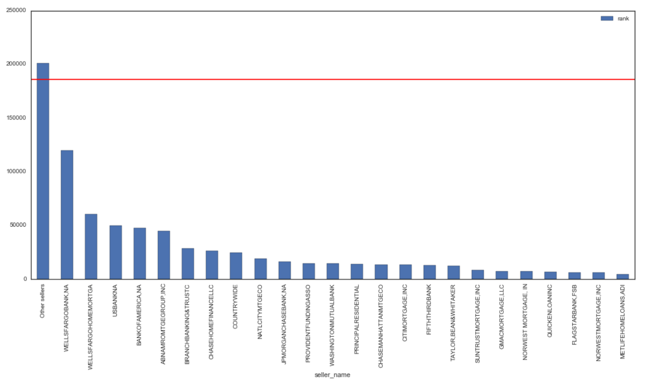

2.1 Analysis - Tableau

**Interest Rate and Delinquency analysis**

The trends of average of Max Delq Sts (actual & forecast) and average of Int Rt (actual & forecast) for ORIGYEAR Year. Color shows details about Forecast indicator.For pane Average of Max Delq Sts (actual & forecast) : The marks are labeled by average of Max Delq Sts (actual & forecast) . For pane Average of IntRt (actual & forecast) : The marks are labeled by average of Int Rt (actual & forecast). The view is filtered on ORIGYEAR Year, which keeps 18 of 18 members.

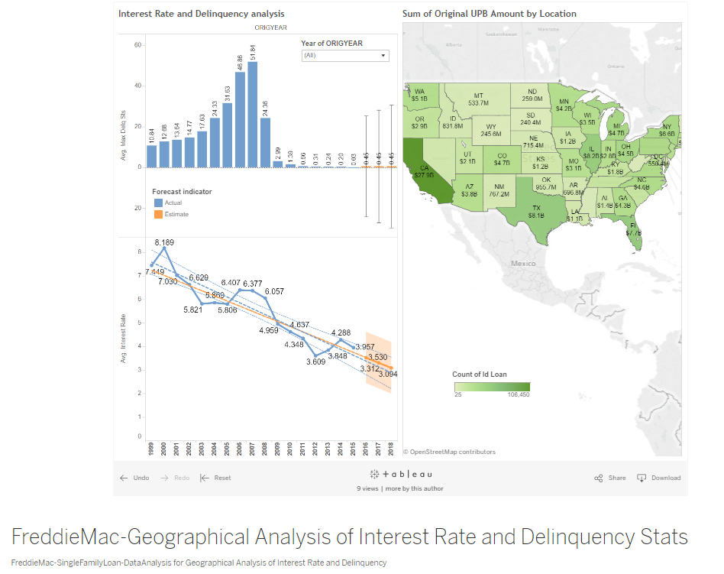

**Link**:

https://public.tableau.com/profile/ankit.bhayani - !/vizhome/FreddieMac-SingleFamilyLoan-DataAnalysis_1/GeographicalAnalysisofInterestRateandDelinquency

**Numerical Measures with Time**

The trends of count of Id Loan, sum of Orig Upb and average of Orig Upb for ORIGYEAR Year. For pane Count of Id Loan: The marks are labeled by count of Id Loan. For pane Sum of Orig Upb: The marks are labeled by IF SUM([Orig Upb])>=1000000000 THEN "$"+STR(ROUND((SUM([Orig For

pane Average of Orig Upb: The marks are labeled by average of Orig Upb. The view is filtered on ORIGYEAR Year, which keeps 18 of 18 members.

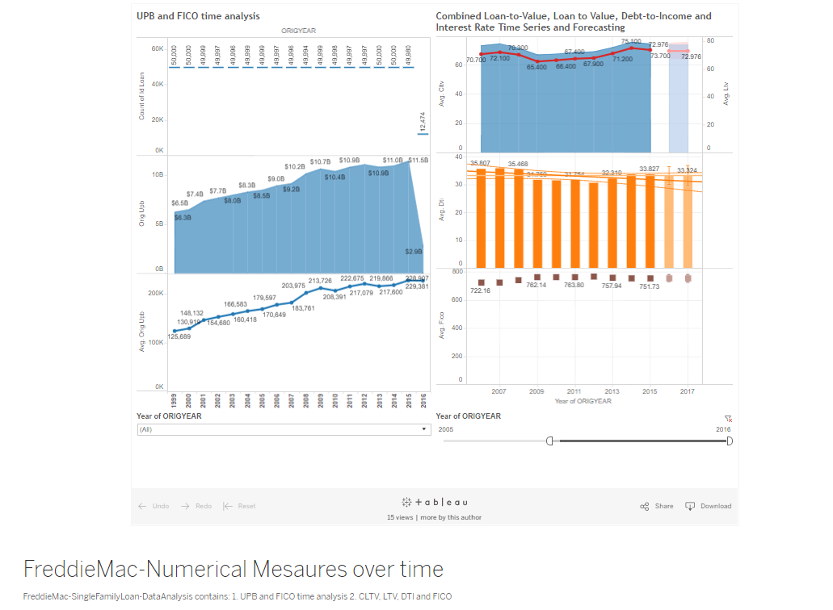

**Link:**

<https://public.tableau.com/profile/ankit.bhayani#!/vizhome/FreddieMac-SingleFamilyLoan-DataAnalysis_0/NumericalMesauresovertime>

**Channel/Seller/Occupancy Insights**

Average of Int Rt and average of Orig Upb for each Prop Type broken down by Occpy Sts. For pane Average of Int Rt: The marks are labeled by average of Int Rt. For pane Average of Orig Upb: The marks are labeled by average of Orig Upb. The data is filtered on Action (Seller Name), which keeps 103 members

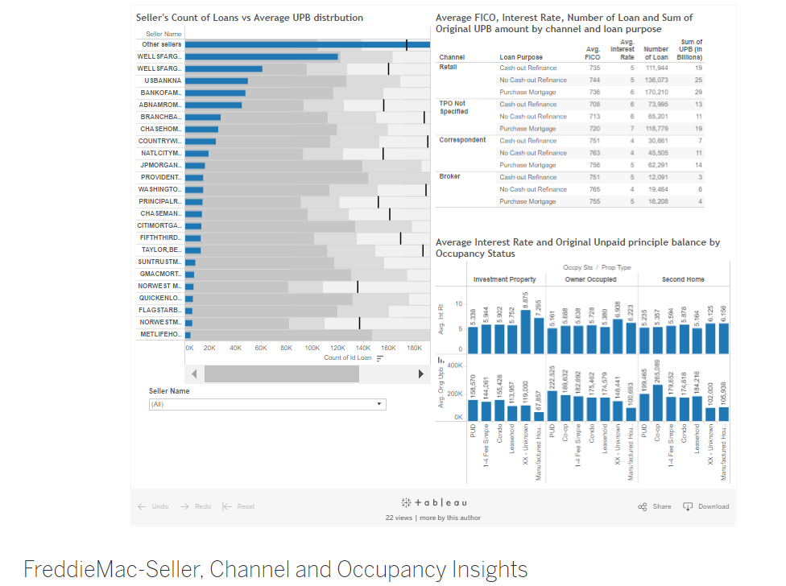

**Link:**

<https://public.tableau.com/profile/ankit.bhayani#!/vizhome/FreddieMac-SingleFamilyLoan-DataAnalysis/SellerChannelandOccupancyInsights>

**Summary**:

* FICO declined in 2013 and 2014, but remained higher than pre-recession levels.
* LTV was 76.6% in 2014 - a new high since 2000, largely due to the increase of purchase volume over refinances.
* DTI went up in 2013 and 2014, however the concentration in the highest DTI bucket (45-65) remained below the pre-recession average.

As the economy continued to recover, Freddie Mac’s loan-level origination data shows a marked increase in the volume of purchase loans, and to a lesser extent investment properties.

2 PART II: Building & Evaluating Models

**PREDICTION (Predicting Interest Rates)**

Here we are going to create a predictive model based on information from the origination data from the prior quarter using the various regression technique to calculate the following metrics:

**MAE (Mean Absolute Error) -** In [statistics](https://en.wikipedia.org/wiki/Statistics), the mean absolute error (MAE) is a quantity used to measure how close forecasts or predictions are to the eventual outcomes.

**RMSE (Root Mean Square Error) -** The root-mean-square deviation (RMSD) or root-mean-square error (RMSE) is a frequently used measure of the differences between values (sample and population values) predicted by a model or an estimator and the values observed. The RMSD represents the [sample standard deviation](https://en.wikipedia.org/wiki/Sample_standard_deviation) of the differences between predicted values and observed values. These individual differences are called [residuals](https://en.wikipedia.org/wiki/Errors_and_residuals_in_statistics) when the calculations are performed over the data sample that was used for estimation, and are called prediction errors when computed out-of-sample. The RMSD serves to aggregate the magnitudes of the errors in predictions for various times into a single measure of predictive power. RMSD is a good measure of [accuracy](https://en.wikipedia.org/wiki/Accuracy_and_precision), but only to compare forecasting errors of different models for a particular variable and not between variables, as it is scale-dependent

**Median Absolute Error-** The [median_absolute_error](http://scikit-learn.org/stable/modules/generated/sklearn.metrics.median_absolute_error.html#sklearn.metrics.median_absolute_error) is particularly interesting because it is robust to outliers. The loss is calculated by taking the median of all absolute differences between the target and the prediction.

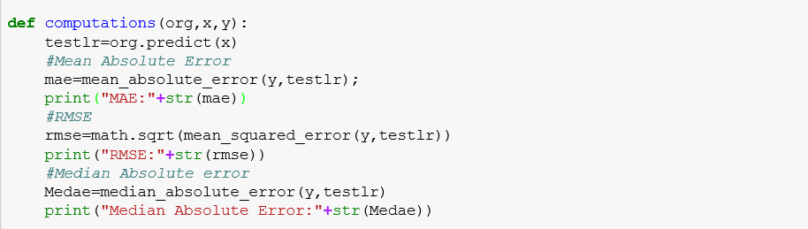

2.1 APPROCH - PREDICTION

     

2.1.1 CREATING THE FUNCTION AND DOWNLOAD THE INPUT

We have created functions that would take hit the Freddie Mac website and download all the Historical file for our purpose. Based on the input Quarter, the file will be imported into python Data Frame. It went through following preprocessing before building model.

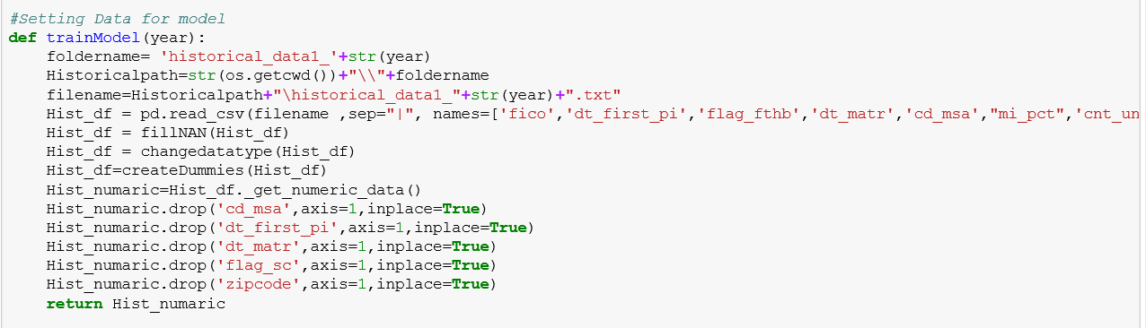

Handling the missing values:

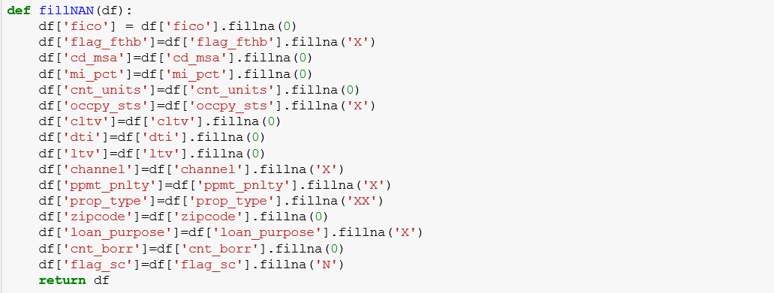

Created dummy columns (1…C):

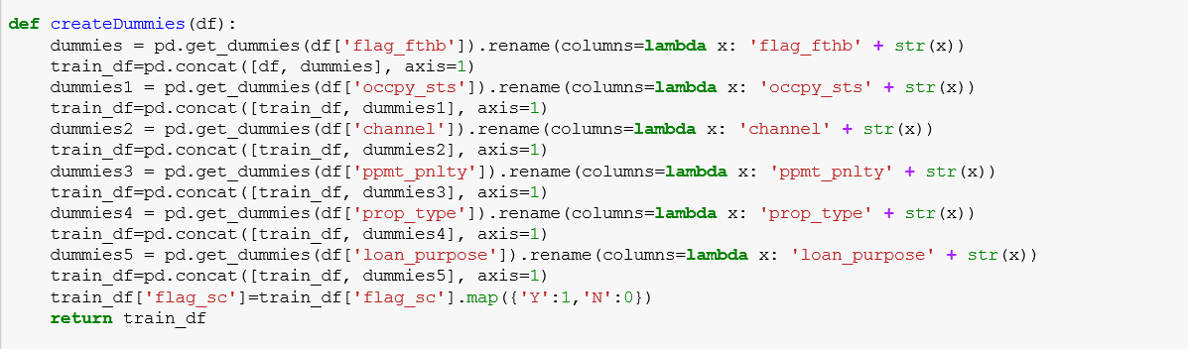

2.1.2 CONVERSION OF DATA TYPE

Data types of the History Origination file is converted as below.

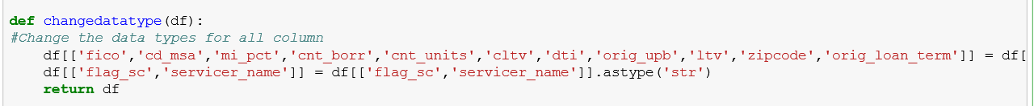

2.1.3 FEATURE SELECTION

Before proceeding with our models, we have done best feature selection using three algorithms.

The best features that add to the predictive power of the model and irrelevant features removed from the model. We implemented following feature selection techniques in Python:

[**sklearn.feature_selection**](http://scikit-learn.org/stable/modules/classes.html#module-sklearn.feature_selection)**.SelectKBest :** Select features according to the k highest scores.

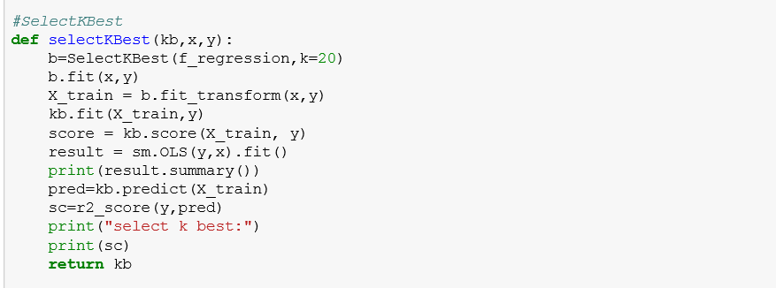

[**sklearn.linear_model**](http://scikit-learn.org/stable/modules/classes.html#module-sklearn.linear_model)**.RandomizedLasso:** Randomized Lasso works by subsampling the training data and computing a Lasso estimate where the penalty of a random subset of coefficients has been scaled. By performing this double randomization several times, the method assigns high scores to features that are repeatedly selected across randomizations. This is known as stability selection. In short, features selected more often are considered good features.

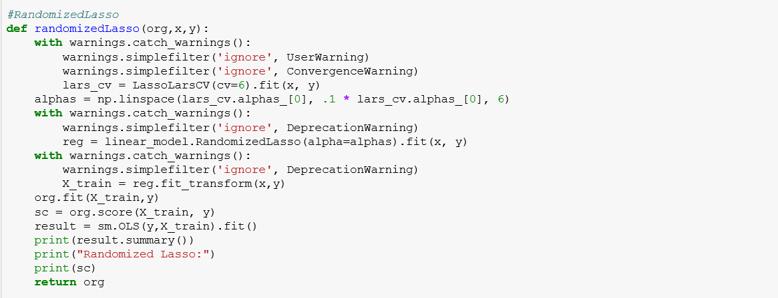

[**sklearn.feature_selection**](http://scikit-learn.org/stable/modules/classes.html#module-sklearn.feature_selection)**.RFE :** Feature ranking with recursive feature elimination.

Given an external estimator that assigns weights to features (e.g., the coefficients of a linear model), the goal of recursive feature elimination (RFE) is to select features by recursively considering smaller and smaller sets of features. First, the estimator is trained on the initial set of features and weights are assigned to each one of them. Then, features whose absolute weights are the smallest are pruned from the current set features. That procedure is recursively repeated on the pruned set until the desired number of features to select is eventually reached.

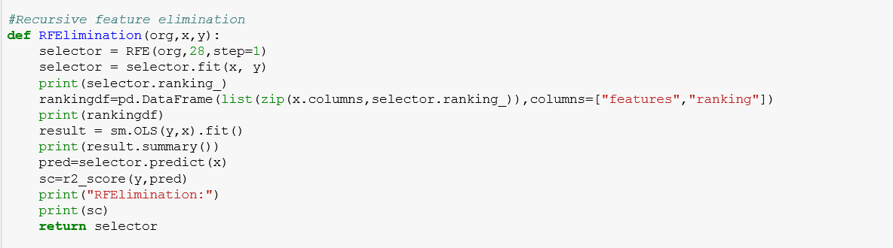

We selected variables as per the **RFE ranking** and used those for further analysis while making sure that all the datasets contain same number of columns. Performing all the feature selection methods we shortlisted below features to best predict our model.

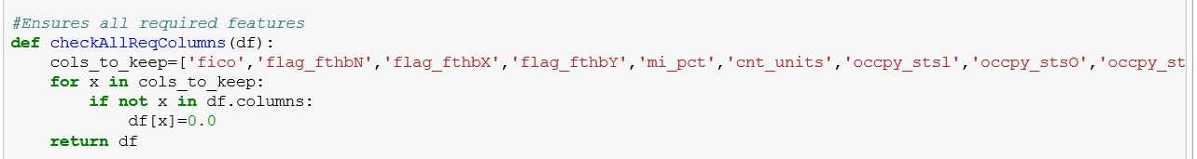

2.1.4 DIFFERENT MACHINE LEARNING ALGORITHMS AND OUTPUT

2.1.4.1 REGRESSION



We have used the following regression techniques and compared the R2 and selected Liner Regression.

**Regression using Linear Regression:**

[**sklearn.linear_model**](http://scikit-learn.org/stable/modules/classes.html#module-sklearn.linear_model)**.LinearRegression :** Ordinary least squares Linear Regression.

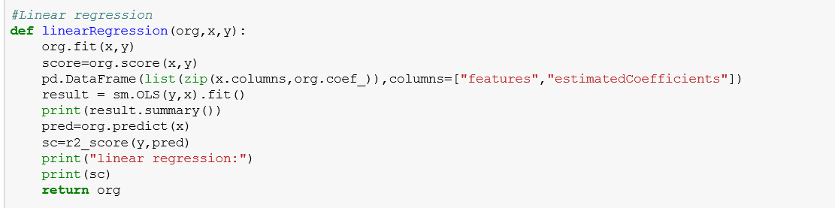

**Regression using LassoLars**

[**sklearn.linear_model**](http://scikit-learn.org/stable/modules/classes.html#module-sklearn.linear_model)**.LassoLars :** Lasso model fit with Least Angle Regression a.k.a. Lars

It is a Linear Model trained with an L1 prior as regularize.

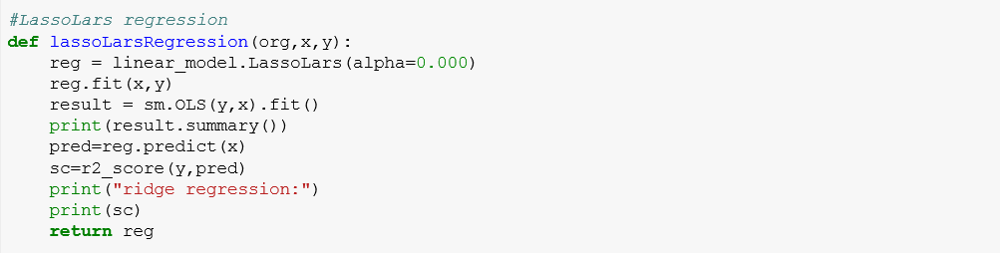

**Implementing Liner Regression**

Linear regression is an approach for modeling the relationship between a scalar dependent variable y and one or more explanatory variables.

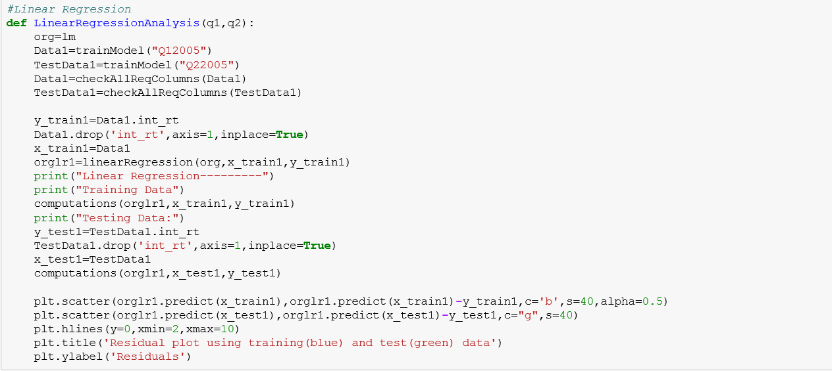

2.1.4.2 KNN



KNN or k-nearest neighbors’ algorithm is one of the simplest machine learning algorithms and is an example of instance-based learning, where new data are classified based on stored, labeled instances. More specifically, the distance between the stored data and the new instance is calculated by means of some kind of a similarity measure.

This similarity measure is typically expressed by a distance measure such as the Euclidean distance, cosine similarity or the Manhattan distance.

[sklearn.neighbors](http://scikit-learn.org/stable/modules/classes.html#module-sklearn.neighbors)**.KNeighborsRegressor**

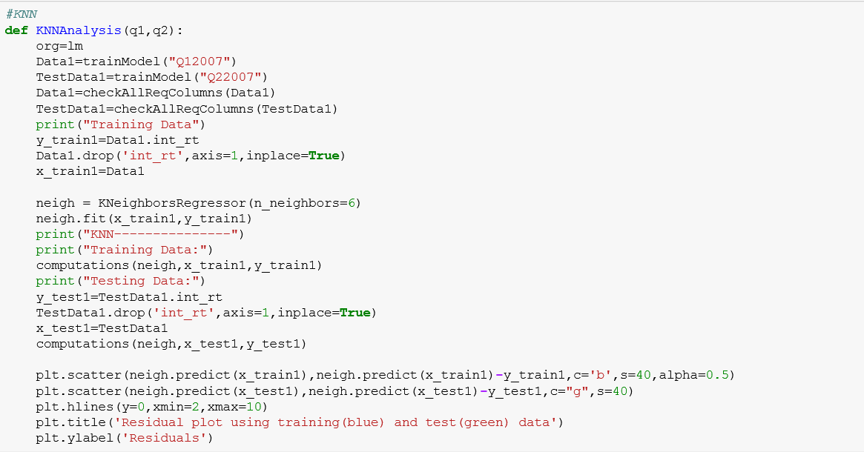

2.1.4.3 RANDOM FOREST



The random forest starts with a standard machine learning technique called a “decision tree”. This is a type of additive model that makes predictions by combining decisions from a sequence of base models.

**sklearn.ensemble.RandomForestRegressor**

A random forest is a meta estimator that fits a number of classifying decision trees on various sub-samples of the dataset and use averaging to improve the predictive accuracy and control over-fitting. The sub-sample size is always the same as the original input sample size but the samples are drawn with replacement if bootstrap=True (default).

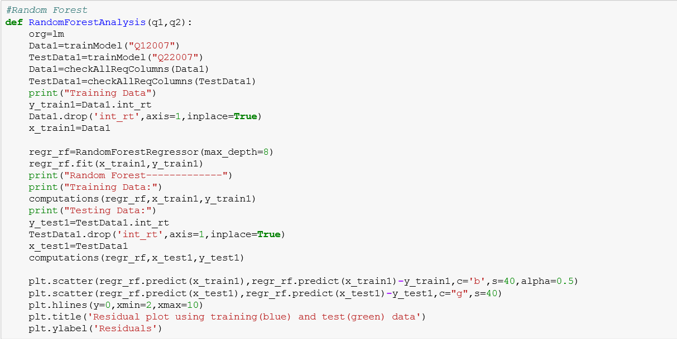

2.1.4.4 NEURAL NETWORK



Neural network terminology is inspired by the biological operations of specialized cells called neurons. A neuron is a cell that has several inputs that can be activated by some outside process.

The artificial equivalent of a neuron is a node (also sometimes called neurons, but I will refer to them as nodes to avoid ambiguity) that receives a set of weighted inputs, processes their sum with its activation function, and passes the result of the activation function to nodes further down the graph.

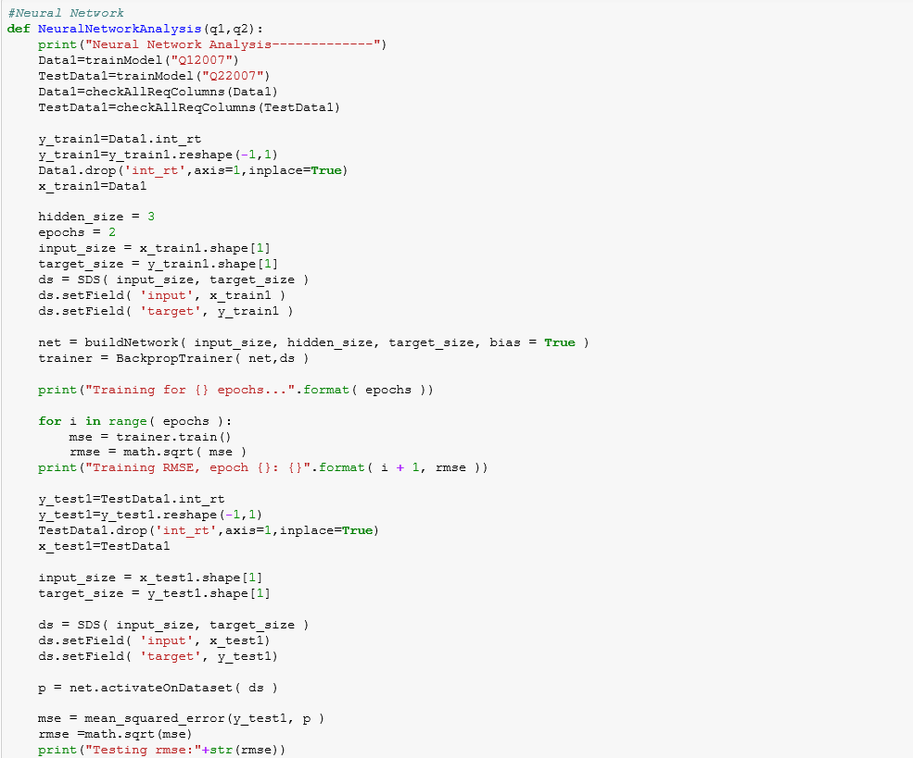

2.1.4.5 STORING AND RETURNING THE RESULTS

We are calculating the results from the different machine learning algorithms, where we are capturing following details:

ModelName, RMSE.baseline, MAE.baseline and Median Absolute error.

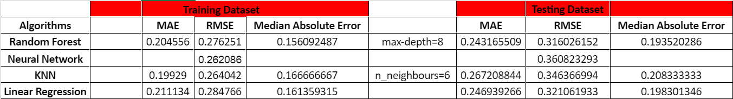

COMPUTE RESIDUALS

We predict the values using our models. We will then calculate the residuals.we can calculate Residuals as shown below, which is nothing but absolute difference of actual verses predicted values.

**Residual Plot for Linear Regression:**

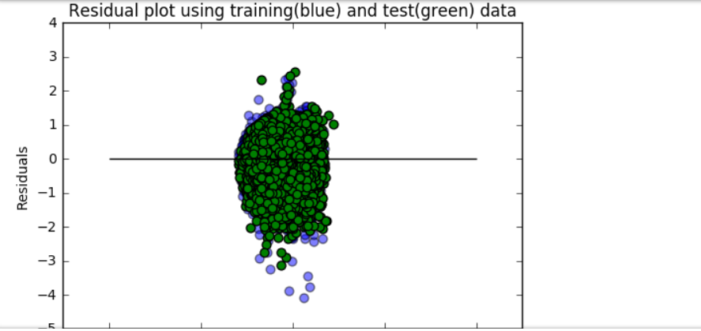

**Residual Plot for Random Forest Regression:**

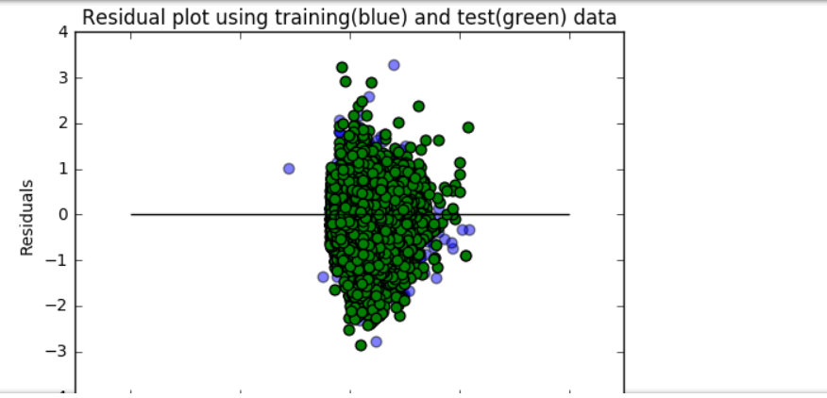

**Residual Plot for KNN:**

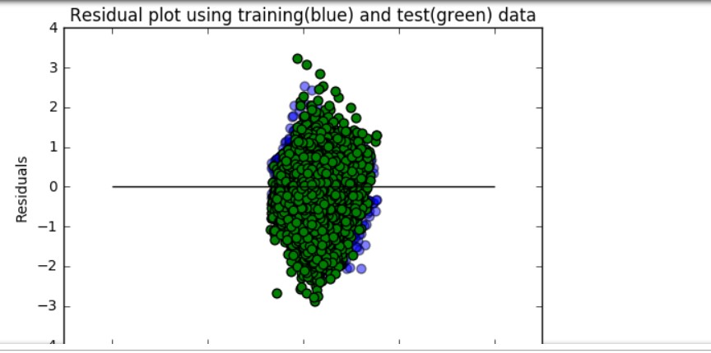

2.1.4.6 PREDICTION MODEL EVALUATION: WHICH MODEL TO CHOOSE

We had compared results of all the models decided **Random Forest** gives us much better result.

1. Higher average predictive accuracy
2. Moderate prediction speed
3. Performs well with large number of observations
4. Handles lots of irrelevant features well

**WHAT -IF Analysis**

**Financial Crisis Analysis**

When the [housing bubble](http://www.investopedia.com/terms/h/housing_bubble.asp) of 2001-2007 burst, it caused a [mortgage](http://www.investopedia.com/terms/m/mortgage.asp) security meltdown. This contributed to a general [credit crisis](http://www.investopedia.com/terms/c/credit-crisis.asp), which evolved into a worldwide [financial crisis](http://www.investopedia.com/terms/f/financial-crisis.asp). Many critics have held the United States Congress - and its unwillingness to rein in [Fannie Mae](http://www.investopedia.com/terms/f/fanniemae.asp) and [Freddie Mac](http://www.investopedia.com/terms/f/freddiemac.asp) - responsible for the credit crisis.

In the fall of 2007, Freddie Mac shocked the market by announcing large credit-related loses, fueling the fire for the argument that the two companies pose a tremendous risk to the entire financial system.

(<http://www.investopedia.com/articles/economics/08/fannie-mae-freddie-mac-credit-crisis.asp>)

The Federal Home Loan Mortgage Corporation (Freddie Mac) announced that it will no longer buy the most risky subprime mortgages and mortgage-related securities.

In July 24, 2007 Countrywide Financial Corporation warned of “difficult conditions.” This is evident from the Q32007 Testing measures as the difference between Training and Testing RMSE increased substantially by around 16%.

In November 1, 2007 financial market pressures intensified, reflected in diminished liquidity in interbank funding markets. This is evident in Q42007 Testing measures as the difference between Training and Testing RMSE increased substantially by around 22%.

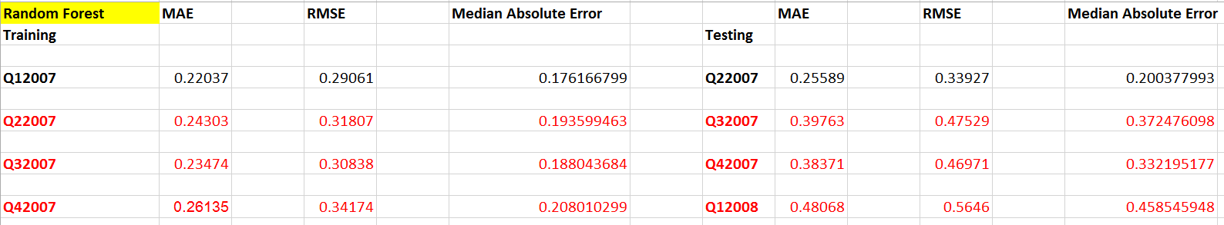

**Two Years Later (2009):**

Financial markets recovered substantially since March 2009 when the financial stress began to ease and market conditions started to improve. ( <http://www.oecd.org/daf/fin/financial-markets/44563803.pdf>)

In 2009, Freddie Mac played a critical role in supporting the nation’s housing market by:

* Providing $548.4 billion of liquidity to the mortgage market, helping finance approximately 2.2 million conforming single-family loans and approximately 253,000 units of multifamily rental housing.
* Helping more than 272,000 borrowers stay in their homes or sell their properties through the company’s long-standing foreclosure avoidance programs and the Home Affordable Modification program (HAMP), including 129,380 loans that remained in HAMP trial periods as of December 31, 2009 according to information provided by the Making Home Affordable (MHA) program administrator.
* Refinancing approximately $379 billion of single-family loans, creating an estimated $4.5 billion in annual interest savings for borrowers nationwide – this includes approximately 169,000 borrowers whose payments were reduced by an average of $2,000 annually under the Freddie Mac Relief Refinance MortgageSM

( <http://www.freddiemac.com/news/archives/investors/2010/2009er-4q09.html>)

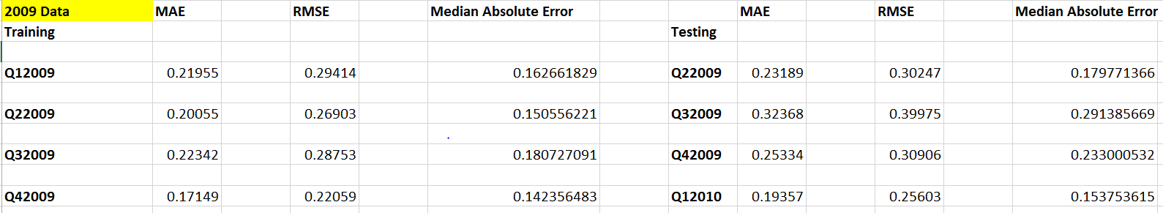

As clearly evident from the analysis, Measures are pretty much stable for 2009.

**Economic Boom (1999,2013):**

**1999:**

The easing of credit also coincided with spectacular stock market run-ups from 1999 to 2000

Freddie Mac financed homes for more than 2 million families and achieved record earnings per share of $2.96, an increase of 28 percent over 1998.

(<http://www.freddiemac.com/investors/pdffiles/annual99.pdf>)

(<https://en.wikipedia.org/wiki/1990s_United_States_boom>)

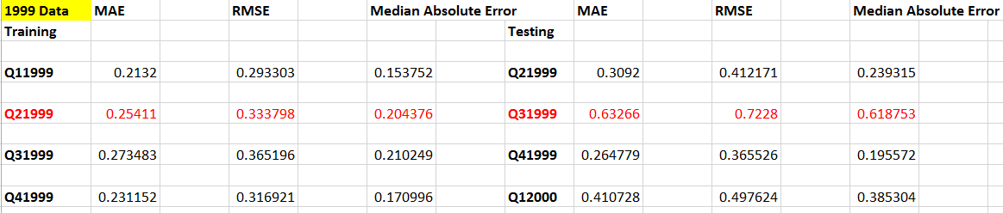

**2013:**

In 2013, Mortgage rates peaked at 4.6% in August and have held steady since September and several accounting events had significant impacts on the Enterprises’ reported financial results. Fannie Mae and Freddie Mac reported levels of 2013 net income are greater than at any prior time in their respective histories. Their historically high net income was driven by reversals of previously accrued losses associated with deferred tax assets (DTA) and their allowance for loan and lease losses (ALLL)—plus revenue from legal settlements of representation and warranties claims and lawsuits regarding private-label securities that the Enterprises purchased as investments. FHFA does not expect benefits of this nature to be repeated in future years and does not expect the 2013 levels of net income to be approached anytime in the foreseeable future.

(<https://www.fhfa.gov/AboutUs/Reports/ReportDocuments/FHFA_2013_Report_to_Congress.pdf#page=18>)

(<http://www.foxbusiness.com/features/2013/12/23/housing-market-in-2013-prices-rise-as-lending-remains-tight.html>)

Drastic change in Training and Testing measures for the highlighted rows clearly shows the transition in economic trends during Q2 and Q3 around 48%.

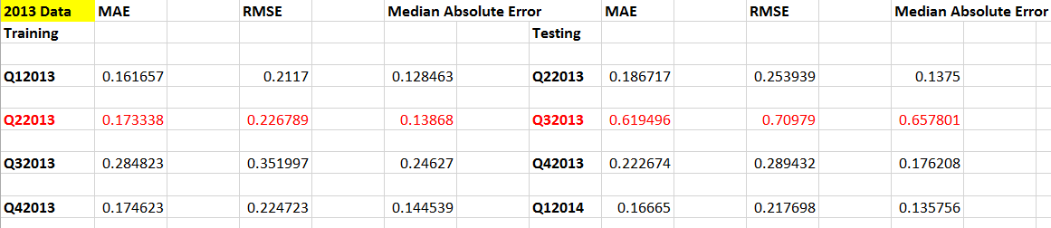

Would you recommend using this model for the next quarter? Justify

The proposed model will perform well for the next quarter with accuracy ranging up to 15% error, if there are not major changes in the data patterns such as financial crisis or economic boom.

**CLASSIFICATION (LOAN DELINQUENCY STATUS)**

In Loan Performance file, we have a column name delq_sts on which we should predict the Loan Delinquency Status by training the data on the quarter provided and predict the result for the next quarter.

3.3 GENERIC APPROACH: CLASSIFCATION

     

2.1.1 CREATING THE FUNCTION AND DOWNLOAD THE INPUT

We have created functions that would take hit the Freddie Mac website and download all the Historical file for our purpose. Based on the input Quarter, the file will be imported into python Data Frame. It went through following preprocessing before building model.

Handling the missing values:

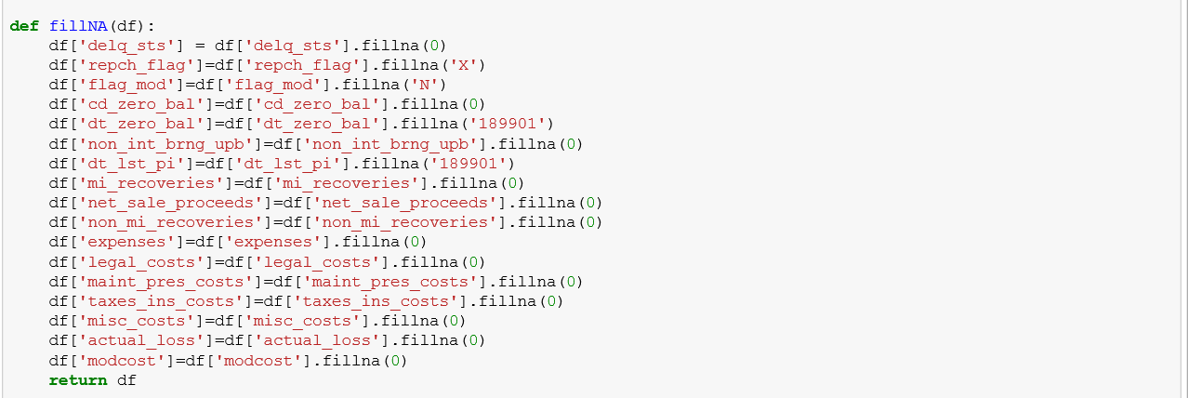

Created dummy columns (1…C):

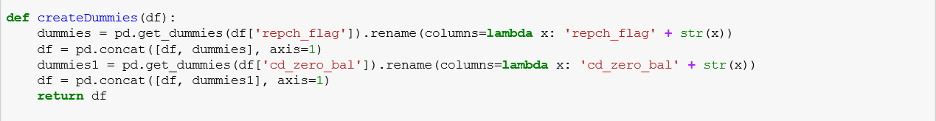

2.1.2 CONVERSION OF DATA TYPE

Data types of the History Performance file is converted as below.

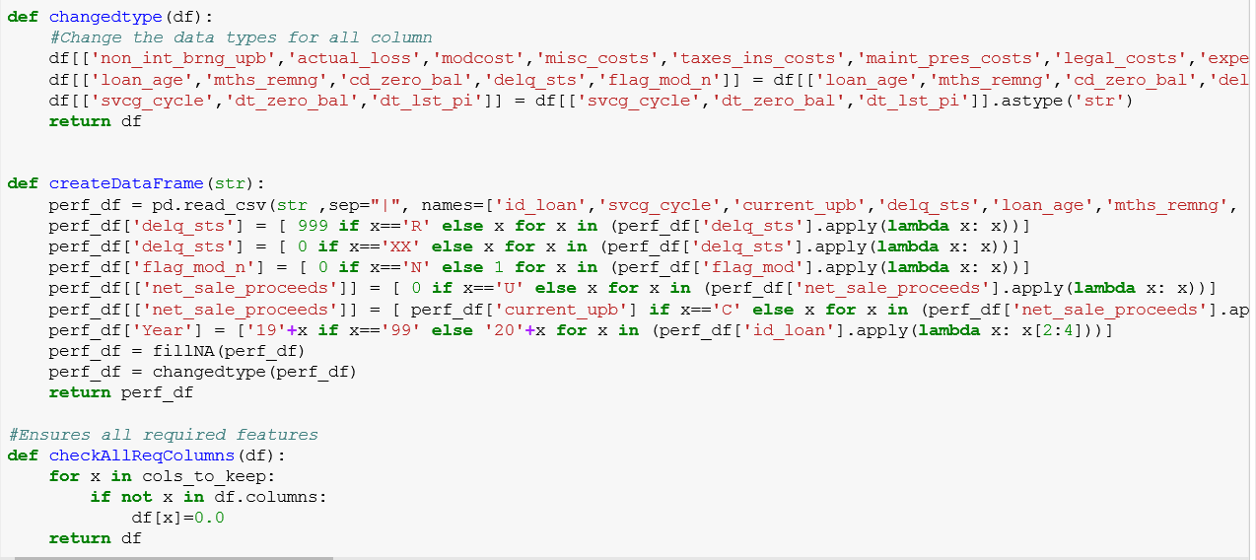

2.1.3 FEATURE SELECTION

Before proceeding with our models, we have done best feature selection using three algorithms.

The best features that add to the predictive power of the model and irrelevant features removed from the model. We implemented following feature selection techniques in Python:

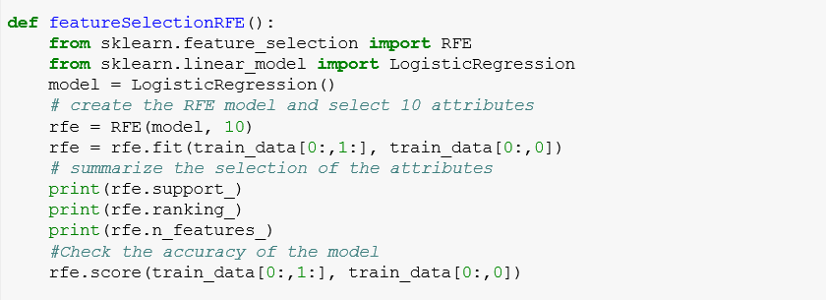

We selected variables as per the **RFE ranking** and used those for further analysis while making sure that all the datasets contain same number of columns. Performing all the feature selection methods we shortlisted below features to best predict our model.

We will discuss the algorithm used in the below section for all the Machine Learning algorithm used for classifications

3.3.1 DIFFERENT MACHINE LEARNING ALGORITHMS AND OUTPUT

1. 3.1.1 LOGISTIC REGRESSION



Binary Logistic Regression is a special type of regression where binary response variable is related to a set of explanatory variables, which can be discrete and/or continuous. We are using the logistic regression model for training the model for the quarter supplied and predicting the delinquency status based on the trained model.

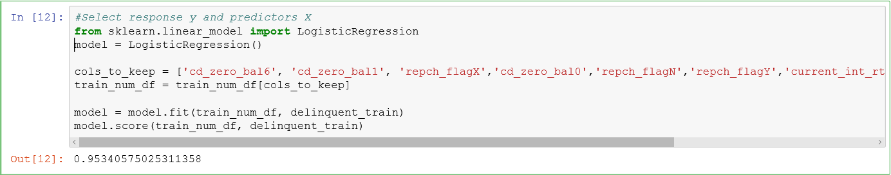

We will calculate the model Coefficient:



Import the following libraries to calculate the logit summary for the logistic regression:

**from sklearn.linear_model import LogisticRegression**

**model = LogisticRegression()**

**import statsmodels.api as sm**

**from statsmodels.formula.api import logit, probit, poisson, ols**

**Apply Logit Function:**

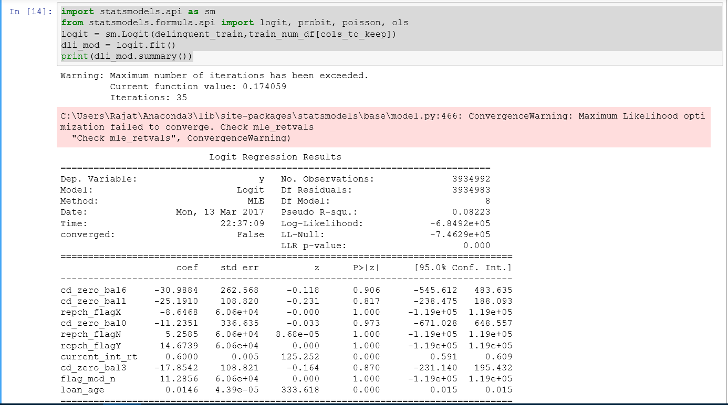

Now predict the delinquency status based on the Test data and generate the accuracy and Classification report.

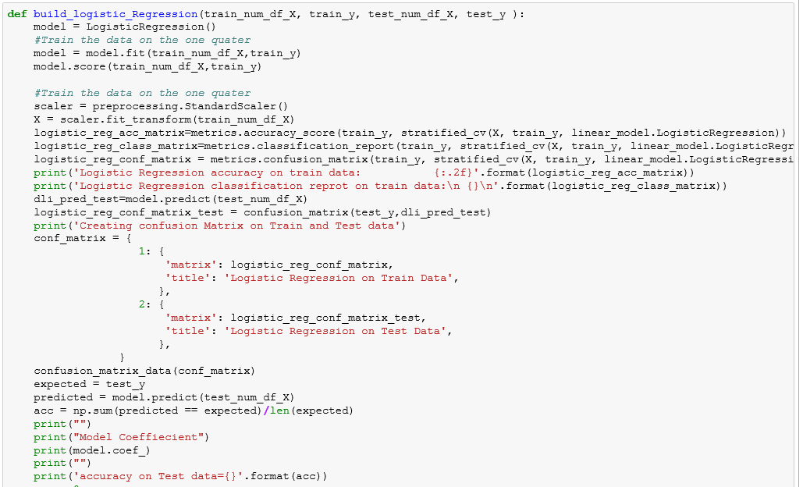

In this case, our function will result the Confusion matrix as shown below and the ROC curve:

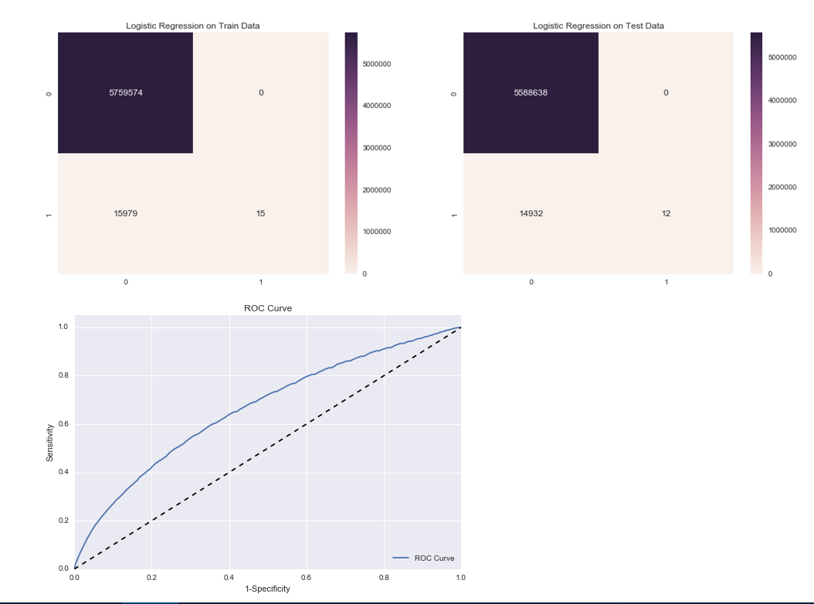

**Accuracy Result & Classification Report**

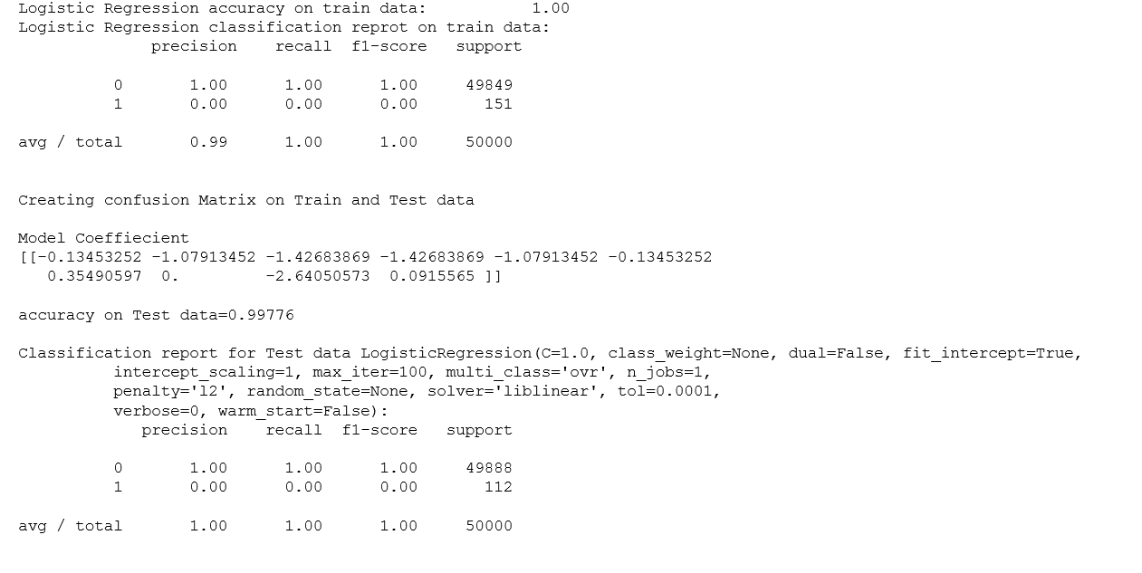







3.3.1.3 RANDOM FOREST

Random Forests grows many classification trees. To classify a new object from an input vector, put the input vector down each of the trees in the forest. Each tree gives a classification, and we say the tree "votes" for that class. The forest chooses the classification having the most votes (over all the trees in the forest).

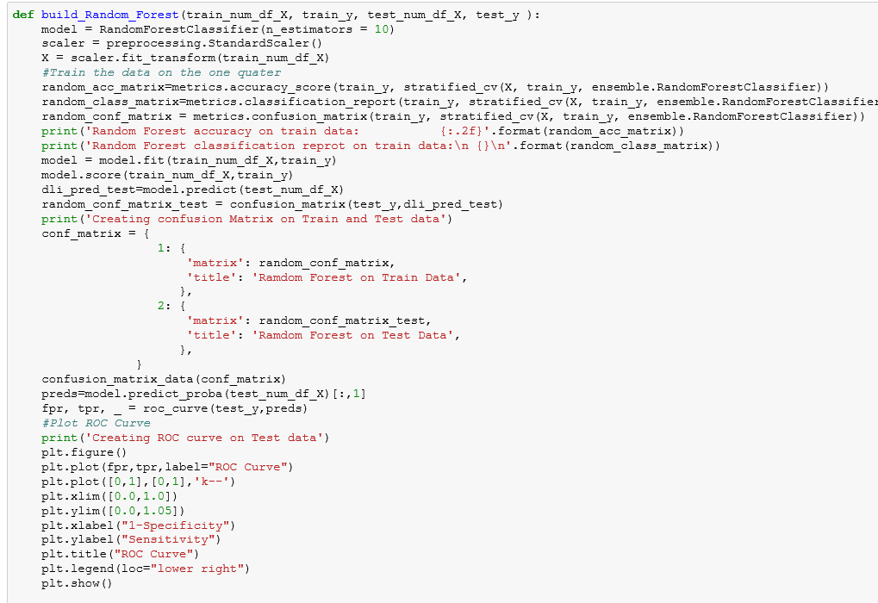

**Accuracy Result & Classification Report**

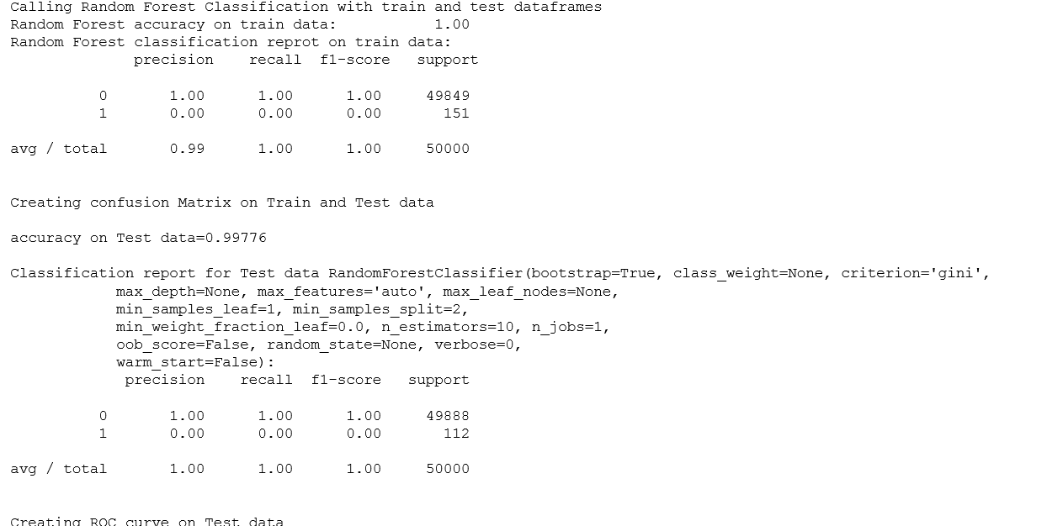

In this case, our function will result the Confusion matrix as shown below and the ROC curve:

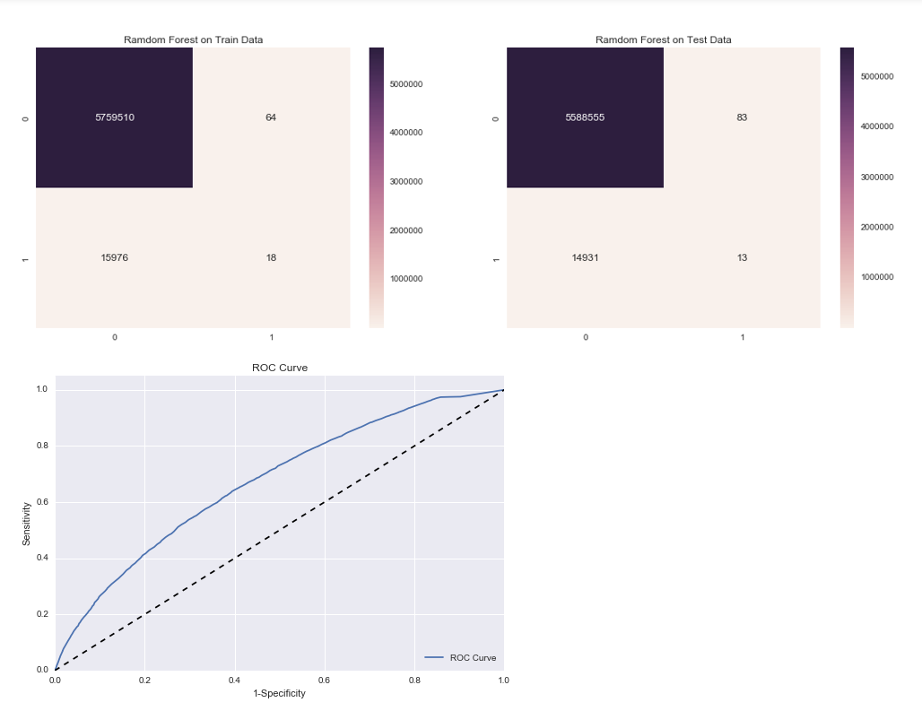

3.3.1.4 NEURAL NETWORK



Artificial neural networks are relatively crude electronic networks of neurons based on the neural structure of the brain. They process records one at a time, and learn by comparing their classification of the record (i.e., largely arbitrary) with the known actual classification of the record.

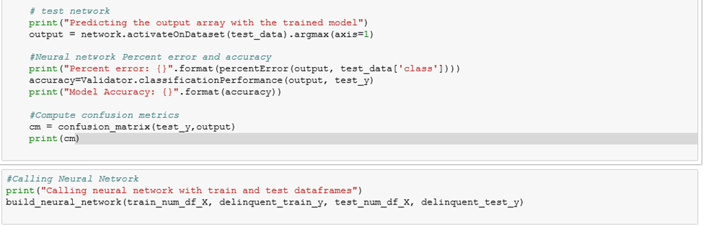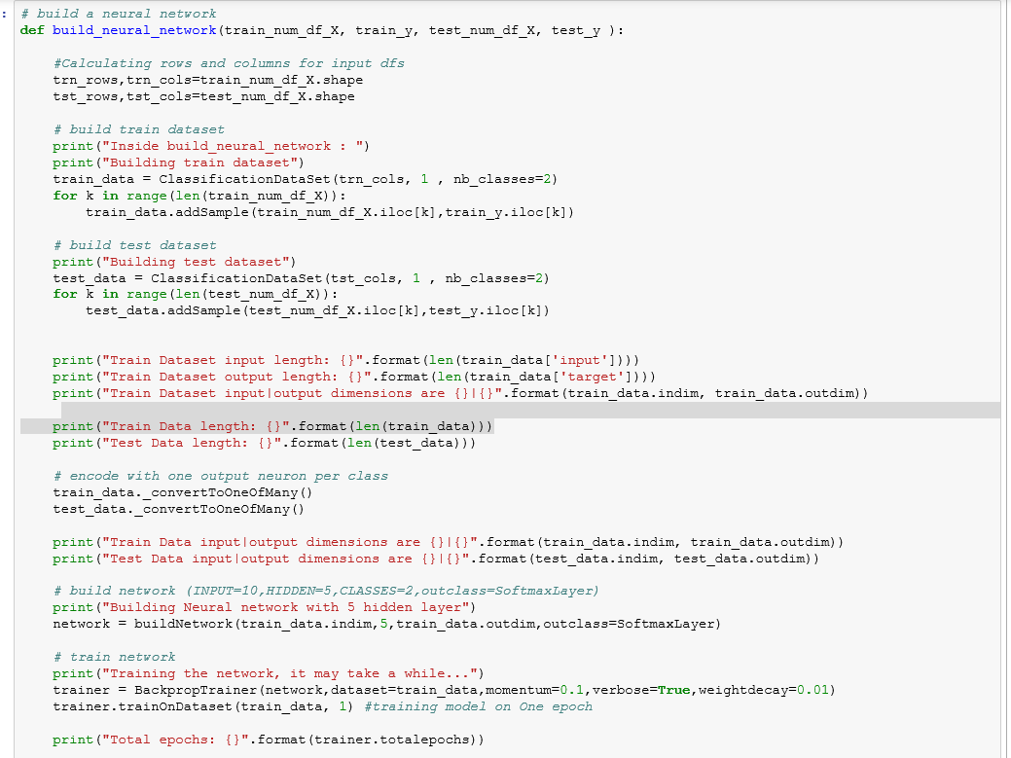

**Accuracy Result & Classification Report**

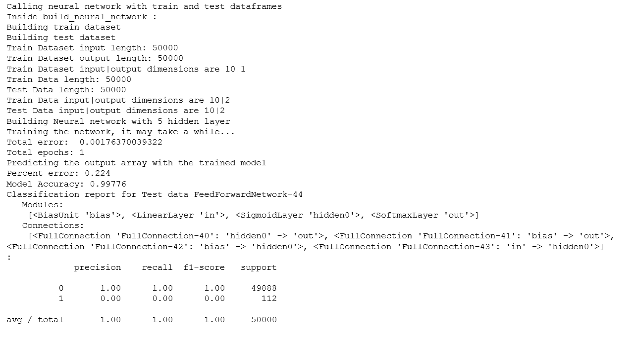

In this case, our function will result the Confusion matrix as shown below and the ROC curve:

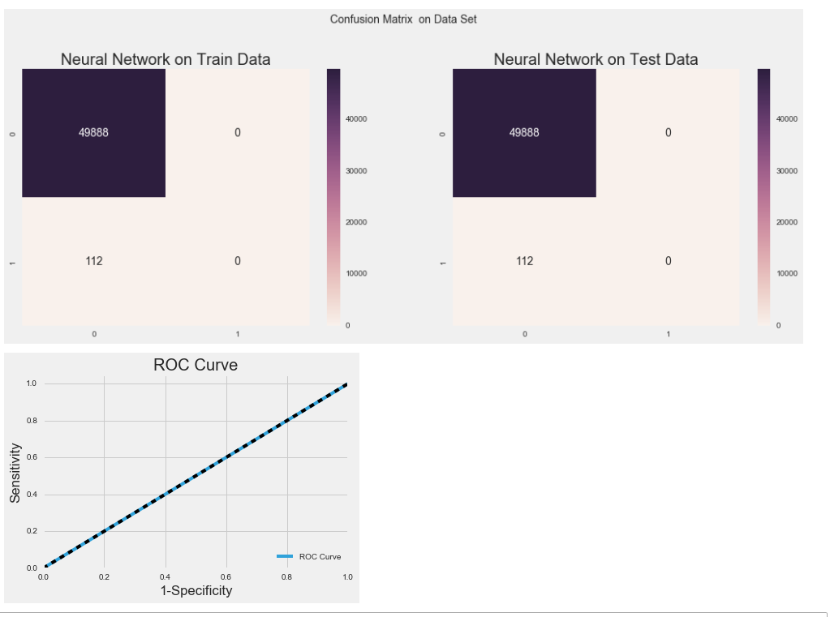

3.3.1.4 SUPPORT VECTOR MACHINE



SVM model is a representation of the examples as points in space, mapped so that the examples of the separate categories are divided by a clear gap that is as wide as possible. New examples are then mapped into that same space and predicted to belong to a category based on which side of the gap they fall.

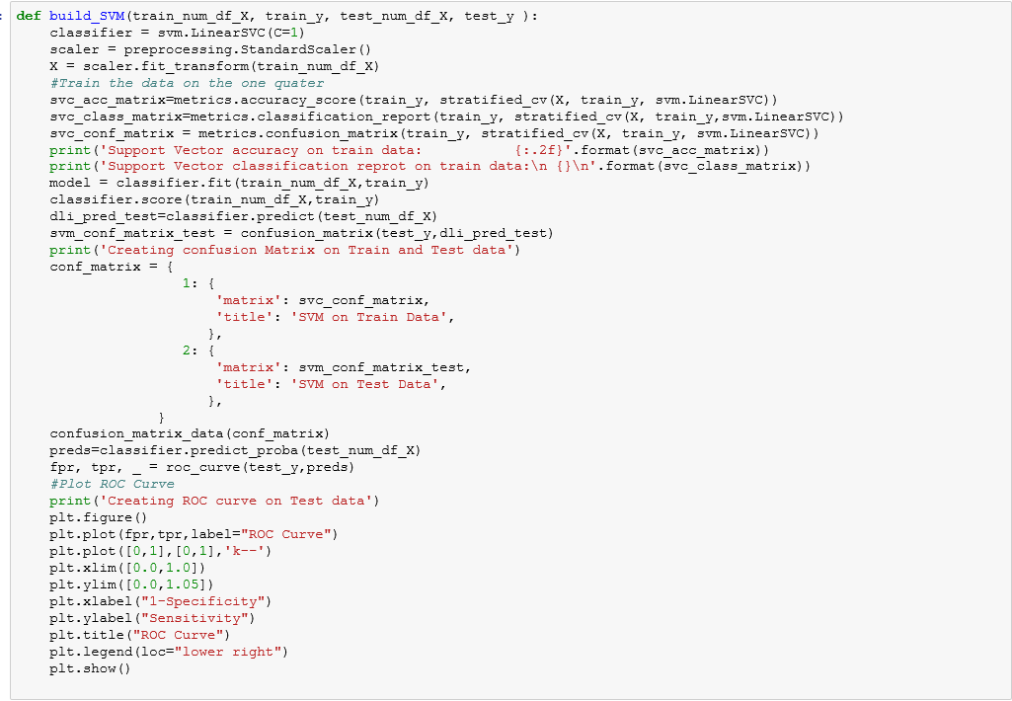

**Accuracy Result & Classification Report**

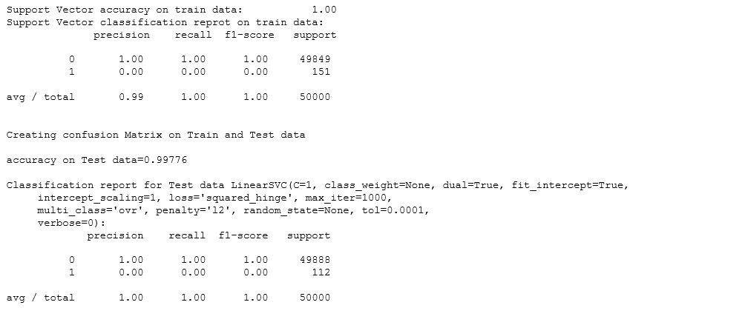



In this case, our function will result the Confusion matrix as shown below and the ROC curve:

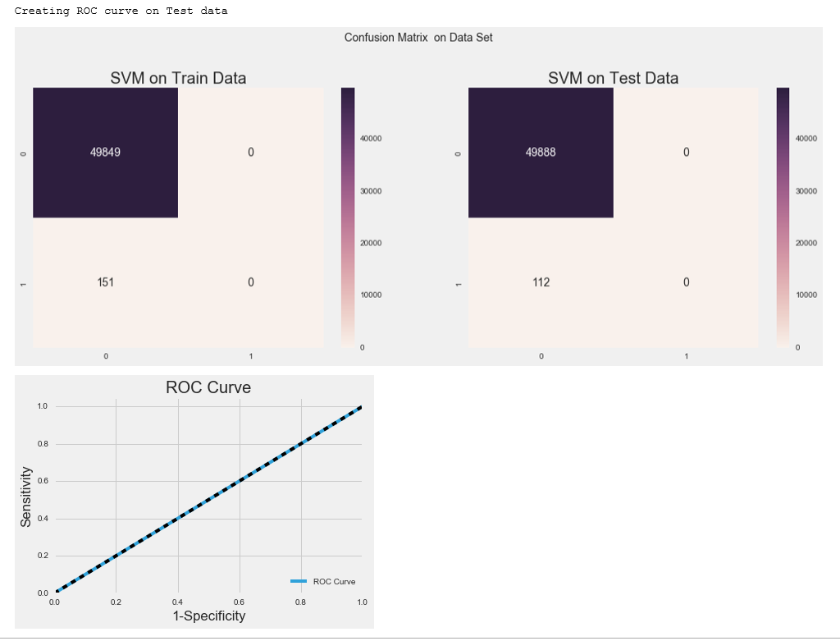

**NOTE: These images does not contain the actual data set but we have used a subset of data set to show the working of our model.**

**Performance Metrics:**

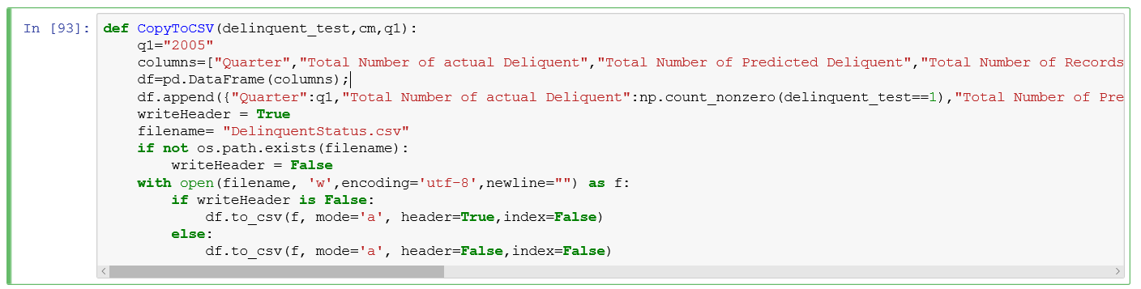

**Comment on the quality of the model and it’s outputs. What can you do to do better? Would you recommend using this model to predict delinquents in the next quarter? Justify your answers**

**Random forest (or random forests) is an ensemble classifier that consists of many decision trees and outputs the class that is the mode of the class's output by individual trees**

Why – Random Forest?

* Rand Forest is fast to build. Even faster to predict!
* Practically speaking, not requiring cross-validation alone for model selection significantly speeds training by 10x-100x or more.
* Automatic predictor selection from large number of candidates
* Resistance to over training
* Ability to handle data without preprocessing
* data does not need to be rescaled, transformed, or modified resistant to outliers
* automatic handling of missing values
* Cluster identification can be used to generate tree-based clusters through sample proximity